FIT FLEX-PROJECT

DOCUMENTATION

1.Introduction

* **Project Title**: Fit Flex- your personal fitness companion
* **Team ID**: NM2025TMID40029
* **Team Leader**: Subha Shree.M & sac2427csc5476@ssacollegechennai.com
* **Team Members**:
  1. Sneha.D &

sac2427csc5364@ssacollegechennai.com

* 1. Sri Harini .Y &

sac2427csc5335@ssacollegechennai.com

* 1. Srividhya.M &

sac2427csc5378@ssacollegehennai.com

1. **Project Overview** 
   * **Purpose**: Fit Flex is a modern fitness and wellness application designed to empower individuals to achieve their health goals effectively. The platform provides personalized workout routines, nutrition guidance, progress tracking, and virtual coaching, all integrated into a single seamless experience. Unlike traditional fitness apps that only focus on one aspects, Fit Flex combines exercise, diet, mental wellness, and performance analytics to give users a complete lifestyle solution.
   * **Features Of Fit Flex**:
     1. User registration and login
     2. Workout and diet planner
     3. Progress tracker (weight, BMI, calories)
     4. Notification and remainder
     5. Admin dashboard

1. **Architecture** 
   * Frontend: React.js with Tailwind/Material UI
   * Backend: Node.js + Express.js
   * Database: MangoDB

1. **Setup instructions** 
   * Prerequisites: Node.js, MongoDB, Git, VS Code
   * Installation Steps:
     1. git clone
     2. cd clients && npm install
     3. cd ../server && npm install

5.**Folder Structure**

* + FitFlex/
  + Client/# React frontend
  + Components/
  + Server/# Backend
  + Routes/
  + Models/
  + Controllers/
  + Docs/# Documentation

1. **Running the Application** 
   * Frontend: cd clients && npm start
   * Backend: cd server && npm start
   * Access: http://localhost:3000
2. **API Documentation**

* **Users**:

POST /api/user/register – Create account

POST /api/user/login –Login

  ➢ **Workouts**:

POST /api/workouts/create – Create a workout plan

GET /api/workouts/:id – Get workout details

* **Nutrition**:

POST /api/nutrition/plan – Generate meal plan

Get /api/nutrition/:userId – Fetch user’s diet plan

* **Progress:**

POST /api/progress/update – Update fitness staus

GET /api/progress/:userId – Get user

progress

1. Authentication
   * JWT-based authentication for secure login
   * Middleware protects private routes

1. User Interface

* + landing Page
  + User Dashboard
  + Workout Planner
  + Progress Tracker
  + Admin Panel

1. Testing
   * Manual testing during milestones
   * Tools: Postman, Chrome Dev Tools

1. Screenshots and Demo

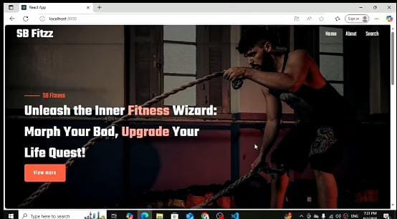

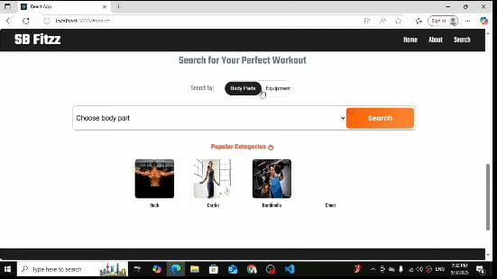

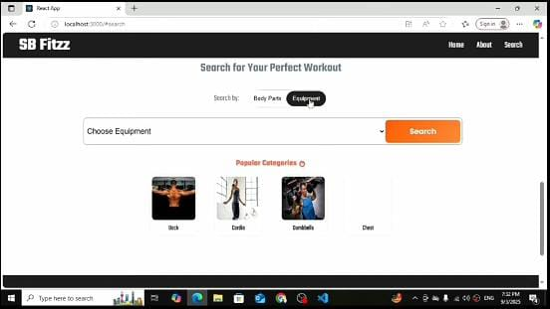

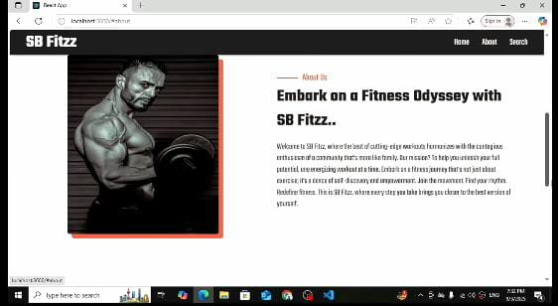

1. Known Issues
   * Privacy and data sharing concerns
   * Subscription and billing issues
   * Content loading and app performance
   * Localization and support
   * Payments & currency conversion

1. Future Enhancements
   * Mobile app version
   * AI-based workout suggestions
   * Social community features